English Learning Journey: Non-Fiction: Recounts and Reports: Real-life mysteries
I am learning how to read recount and report texts.
I am learning how to read a recount, making notes, and developing ideas.

I am learning to explore the impact of adverbs and use them for detail.

I am learning how to write a recount from a different point of view.

I am learning how to use dictionaries to check meanings and definitions.
I am learning to answer questions about an information text.

I am learning how to read a report and organise into topic paragraphs.
In the next few weeks, I will investigate mysteries like Shackleton's ghostly companion to the Loch Ness Monster and friends, read the amazing evidence about these mysterious cases and make up my own mind. I will then discuss, draft, and plan a new recount for real-life mysteries.
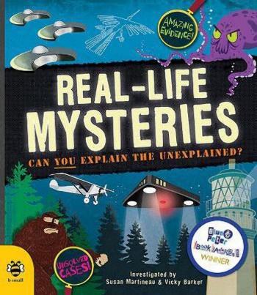
I am learning how to plan a report about an alien, including paragraphs and headings.

I am learning to discuss/plan and draft a new recount for Real-life mysteries.

I can use self and peer assessment to uplevel my writing.

Tier 2 Vocabulary:
advice nation ancient abandon passage
nursery
plunge
schedule
swift

Knowledge and skills: Speaking and Listening: Participate in discussions. Comprehension: Read books that are structured in different ways and read for a range of purposes. Identify how language, structure, and presentation contribute to meaning. Retrieve and record information from non-fiction. Word reading: Read aloud and understand the meaning of new words.

Silver Vocabulary:
with both most only could should eye

Gold Vocabulary:
ordinary occasion experience heard guard actual actually

