English Learning Journey: Poetic forms
I am learning to read and explore kennings.
I am learning to describe and comment on kennings and write an animal kenning.
I am learning to use adjectives and modify adverbs.

I am learning to compose a haiku about the weather.

I am learning to use prepositional phrases in descriptions.

I am learning how to read and recite haiku.

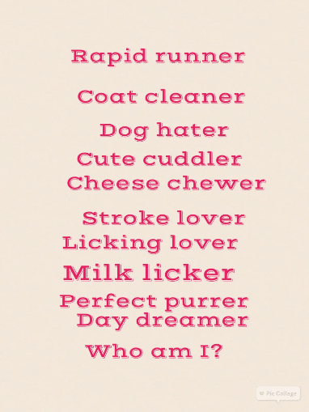
I am learning to read acrostics and explore fronted adverbials.
In the next few weeks, I will study classic and contemporary forms of kennings and haiku, then write my own about animals and the weather. I will learn how to use expanded noun phrases and fronted adverbials in poetry. Explore rhyming ballads and develop my own following the given patterns.
I am exploring ballads and issues raised by rhyme.

Independent Writing: I am learning to write a ballad.

I can plan, compose, and recite a ballad.

Tier 2 Vocabulary: peculiar invisible frantic ease column blossom response ascend
Knowledge and skills: Comprehension Identify themes and conventions in a wide range of books and poems. Recognise some different forms of poetry [for example, kennings].
Composition Discuss writing similar to that which they are planning to write in order to understand and learn from its structure, vocabulary and grammar. Compose and rehearse sentences orally… progressively building a varied and rich vocabulary and an increasing range of sentence structure.
Silver Vocabulary:
strange strength suppose favourite forward consider
Gold Vocabulary:
experiment extreme famous believe

